University of Waterloo

Department of Mechanical and Mechatronics Engineering

MTE 111

Lab 2: Young's Modulus, Stress and Strain

Prof. Yimin Wu

Group #23: Ian Jinzo Macpherson Takeda, Joe Chen, Pedro Brossel, Randy Jayasinghe

June 9th, 2023

**SUMMARY**

This experiment was conducted to calculate different material properties of 5052 aluminum alloy, cold rolled AISI 1010 plain carbon steel alloy, and heat-treated AISI 1010 plain carbon steel alloy. The measurements were conducted in an apparatus that clamped both sides of the specimen to a tensile test machine, and a progressively increasing load was applied on each specimen by rotating the hand wheel until fracture.

The first step was to measure the dimensions of the gauges of the three specimens. To accurately collect the data, a video was taken to record the tensile force applied to the specimen and its extension under said force before fracture. A spreadsheet was then used to copy the data from the video, as well as construct related and useful graphs and tables. Then, the Young’s Modulus was found, and using the data, the values of other properties were determined.

After the experiment, it was concluded that heat-treated steel alloy had the highest Young’s Modulus and mild steel had the lowest, and possible sources of error were explained. The differences in stiffness, yield strength, tensile strength, and percent elongation for all three samples were compared and discussed based on the graphs and tables.

**INTRODUCTION**

Due to a variety of reasons and factors, different materials behave differently when put under stress. These behaviours further differ within the same material when considering the elastic and plastic deformation regions separately. The purpose of this lab was to experimentally determine and calculate several properties of the following three materials via data obtained during a tensile test:

1. 5052 aluminum alloy
2. AISI 1010 plain carbon mild steel, cold-rolled
3. AISI 1010 plain carbon mild steel, heat-treated

The properties that were to be determined included each material’s yield strength, ultimate tensile strength, fracture strength, and percent elongation. This report aims to provide details on how data was gathered during the experiment, as well as to compare the obtained and calculated values for the mentioned properties. These comparisons were made both between the tested materials as well as between the experimentally obtained and theoretically calculated values for said properties in each material. Further, the report aims to provide explanations as to the variation in those properties between each material.

**EXPERIMENTAL PROCEDURE:**

1. Measurement of materials: The three pieces of aluminum, cold-rolled plain carbon steel and heat-treated plain carbon steel had each gauge’s complete length, width, and thickness measured from three points along the length, and the averages of the three values were calculated and logged. This was done to account for the fluctuations in each dimension along the sample gauge.
2. Setup: Using the provided apparatus, each specimen was placed in the specified slot and held in place by the wedge grips. The force gauge, the calipers attached to the tensile tester, and the data-logging software parameters were all set to zero. When the experiment was started, a video was taken to record the force applied and the resulting extension values measured by the calipers, and the hand wheel was rotated counterclockwise at an approximately constant speed, while the software graphed the data. The rotation did not stop until the material fractured into two pieces. Finally, the number of rotations was recorded, and the new gauge length was measured.

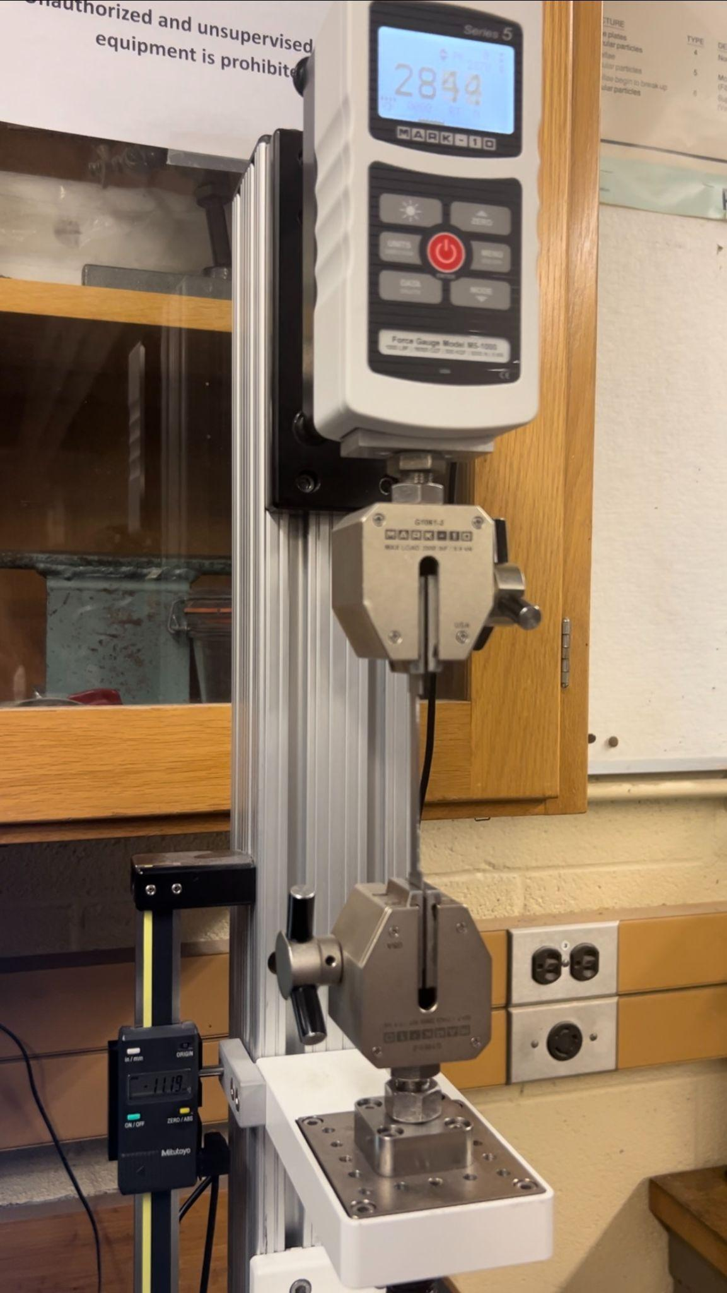

Figure 1: Front view of the Table-top tensile machine

**RESULTS:**

Graphical Analysis of Each Sample:

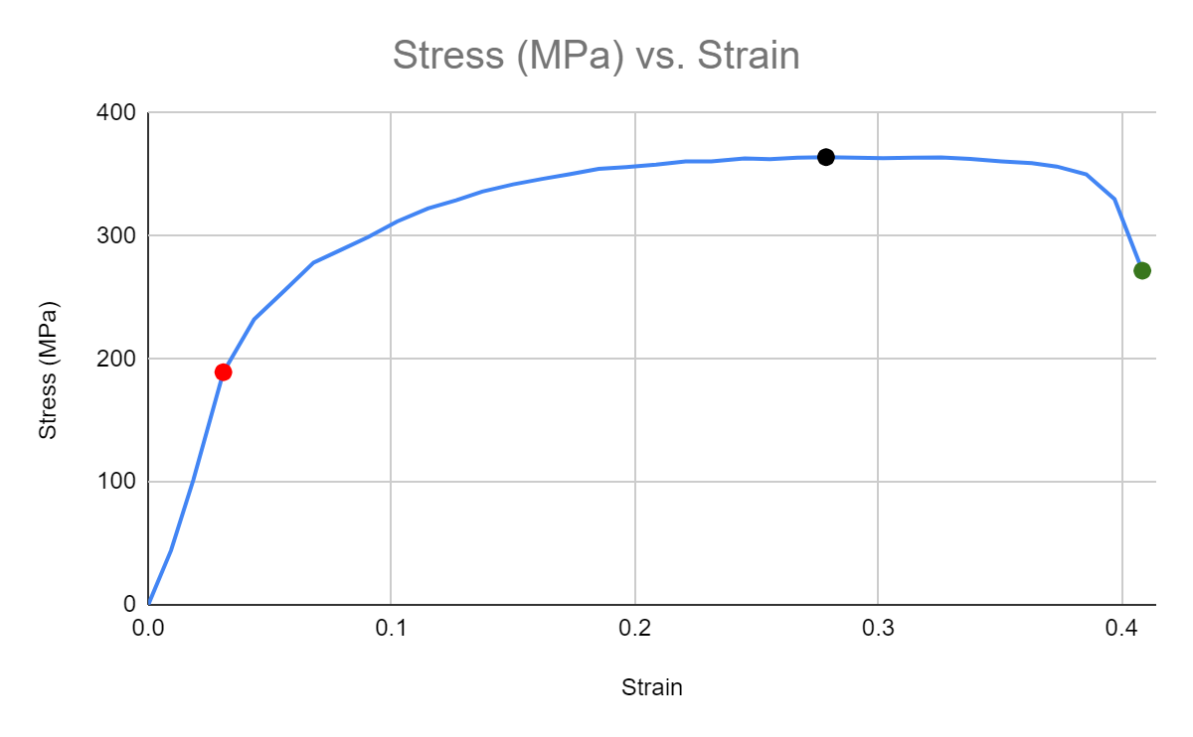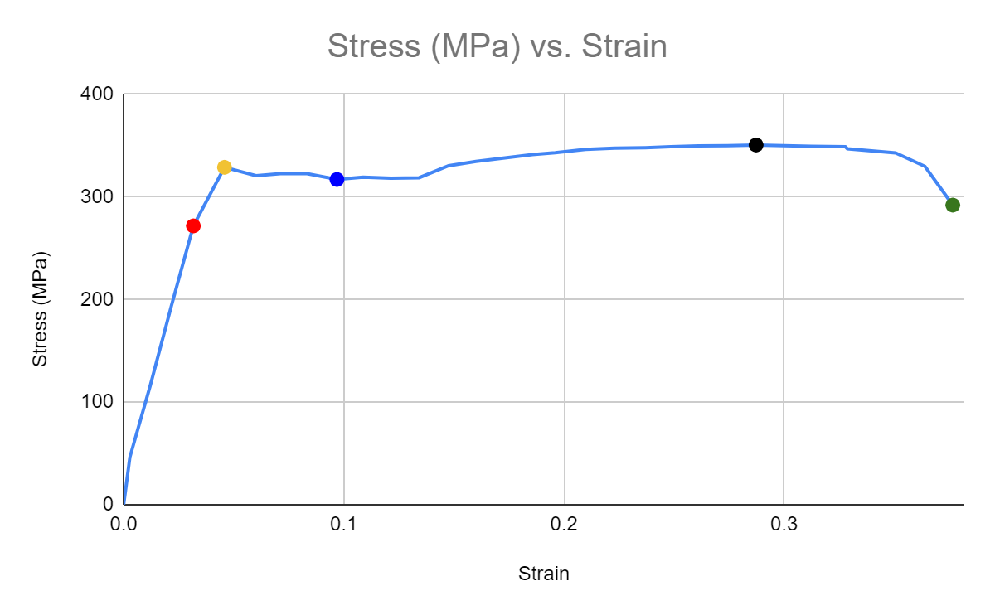



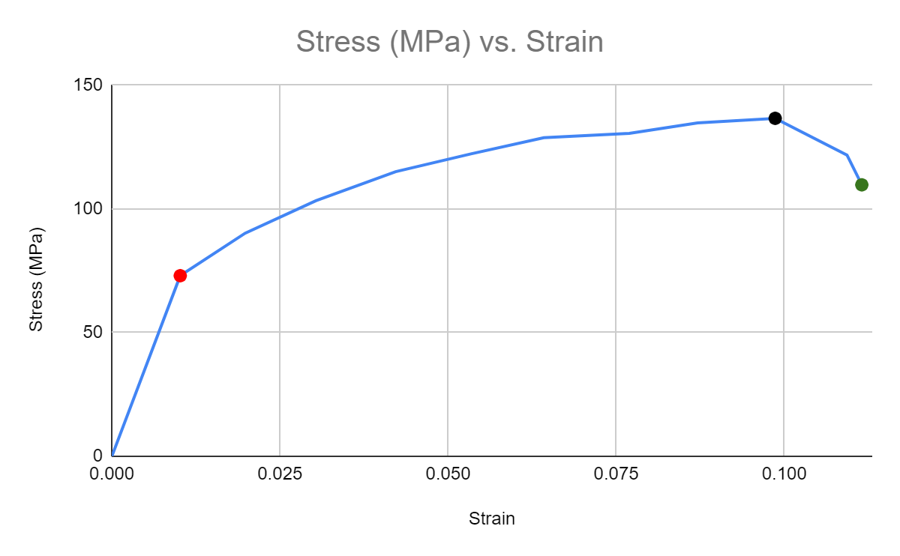



The three stress-strain graphs (Figs. 2-4) were plotted using the force-extension graphs obtained from the values measured during the experiments. In each graph, the data point highlighted in red signifies the approximate point at which each material begins to show plastic deformation (i.e. each material’s elastic limit). This was selected by analyzing each graph and estimating where its linear region ended. The data point highlighted in black is the ultimate tensile strength of each material (i.e. the point at which the sample experiences the most stress). Finally, the data point highlighted in green is the material’s fracture point (i.e. the stress/strain combination the sample experiences immediately before breaking).

In addition to the above described points, Fig. 2 (the stress-strain curve for heat-treated steel) shows the material’s upper and lower yield points, highlighted in yellow and blue, respectively.

Calculation of Young’s Modulus for Each Material:

As the line leading up to the elastic limit (as seen in the stress-strain curves above) can be considered a straight line, the Young’s Modulus for each material was taken to be the gradient at each material’s yield point.

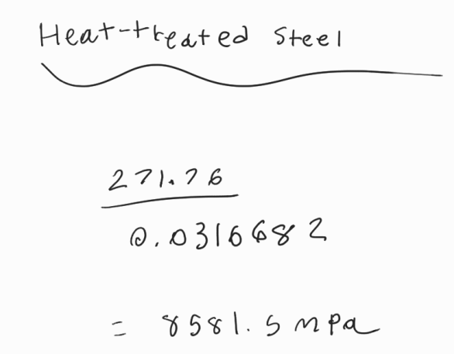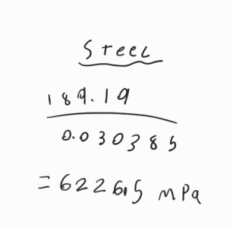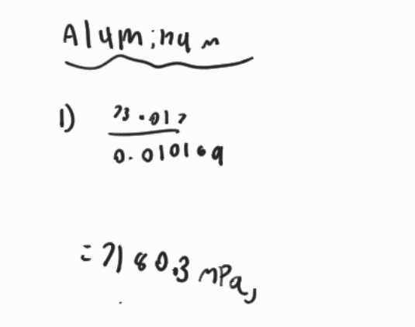



Comparison of Properties:

| **Material** | **0.2% Offset Yield Strength (MPa)**  **OR**  **Upper and Lower Yield Points (MPa)** | **Ultimate Tensile Strength (MPa)** | **Fracture Strength (MPa)** | **% Elongation** |
| --- | --- | --- | --- | --- |
| Aluminum | 83.93 | 136.64 | 109.75 | 9.33 |
| Mild Steel | 213.28 | 364.13 | 271.75 | 34.77 |
| Heat-Treated Steel | Upper Yield Point: 328.87  Lower Yield Point: 317.02 | 350.64 | 350.60 | 31.97 |



The 0.2% offset yield strength was found by plotting a line with a slope equal to the Young’s Modulus calculated previously. The point of intersection of the offset line and the stress-strain curve is the 0.2% offset yield strength for each material. The graphs with both lines for aluminum and steel can be found below.

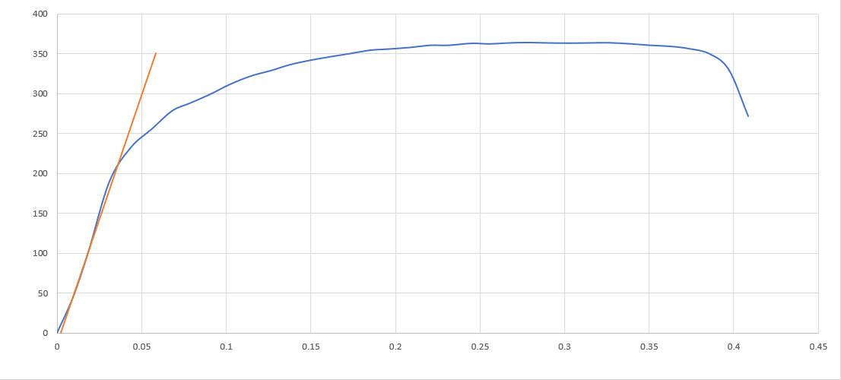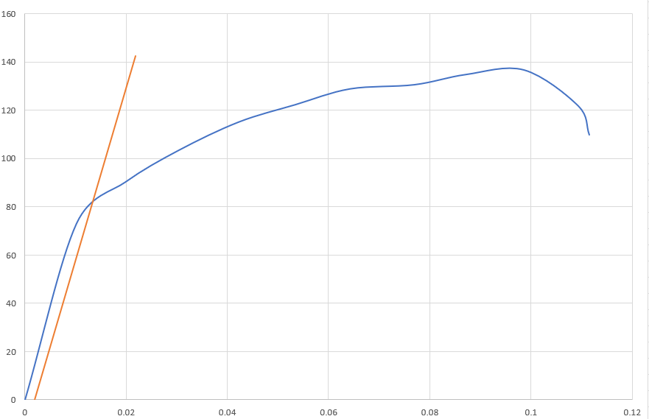



**DISCUSSION:**

Comparison of Experimental and Theoretical Values for Young’s Modulus

The theoretical value of the Young’s Modulus of aluminum is 70 GPa [1]. Mild steel has a range of 180 - 210 GPa [2]. Heat-treating steel does not significantly change its structure and composition, therefore heat-treated steel has the same range of Young's Modulus values as mild steel [2].

From the calculations done to determine the experimental Young's Modulus, aluminum was found to have had a Young’s Modulus of 7.18 GPa. Mild steel had a Young's Modulus of 6.23 GPa and heat-treated steel had a Young’s Modulus of 8.58 GPa .

This discrepancy between the theoretical and experimental errors is primarily attributed to impurities present in the samples, as well as minor impacts from errors in the experimental procedure.

Aluminum has common impurities, such as oxides, that greatly reduce the material’s ductility. When oxides are trapped in aluminum, it disrupts the distribution of stress and can generate non-uniform plastic and elastic deformation in the material, greatly impacting the tensile strength, yield strength and fracture strength [3]. This greatly reduces the ductility of aluminum and thus the value of its Young’s Modulus. Additionally, impurities added to steel such as copper, chromium, tin and nickel impact its ductility [4]. The more present these types of insertions are, the more the steel’s tensile strength increases. However, the presence of these impurities simultaneously decreases the ductility of steel. This can be seen on both heat-treated steel as well as regular mild steel and provides an explanation as to why the margin of error was so great.

Furthermore, the equipment used to conduct the tensile test may have resulted in cumulative errors in tracking the change in position and force applied on the material, leading to errors in measured values, which would be carried forward in any calculations and/or graphs. The clamping mechanism also could have contributed to the error since there could have been a lack of sufficient friction to avoid the sample from slipping in the grips. Additionally, if an extensometer was used instead of the available equipment, the extension recorded would have been more accurate since that is the only property tracked by an extensometer. This allows it to have more accurate results when calculating the strain of a material [5].

Difference In Stiffness Between Aluminum and Steel

The difference in stiffness between aluminum and steel is due to the differences in Young's Modulus, density, and atomic structure of each material. Young's Modulus is the relationship between the stress and strain experienced by a material. It helps to determine how much materials extend when force is applied. Since the theoretical Young's Modulus of aluminum (70 GPa) [1] is three times smaller than the Young's Modulus of steel (210 GPa) [2], this means that the aluminum sample would experience a greater extension than steel under the same stress. The Young’s Modulus of the three materials relies heavily on their respective microstructures, where aluminum’s FCC structure is less stiff because of its easy-to-slip closed packed planes and low carbon steel’s BCC structure is more stiff because of the lack of ideal closed packed planes, and thus, it is less likely to slip. Density also impacts the stiffness of a material, because the more dense it is, the more rigid it becomes [6]. Steel typically has a density of 7.75 to 7.89 grams per cubic centimeter, while aluminum has a density of 0.0160 to 3.63 grams per centimeter cubed [7]. Since steel is much denser, it deforms less when it is under stress. Therefore, since aluminum is more likely to slip due to its atomic structure, has a smaller value for Young’s Modulus, and has a lower density, it can be concluded that it is less stiff than steel.

Comparison of Yield Strengths

As seen from Table 1, the material found to have the lowest measured yield strength (taken from the calculated 0.2% offset yield strengths) was aluminum (83.93 MPa). Conversely, the material with the highest yield strength was heat-treated steel. Given that the yield strength oscillates about the lower yield point, using the average of the stresses experienced around this lower yield point, the yield strength of the heat-treated sample was calculated to be 318.17 MPa. The two main reasons for the considerable variation of yield strengths that will be explored are the differences in molecular structure between the two materials, and the method of preparation for both samples.

Though the 5052 aluminum alloy is a mix of aluminum and magnesium atoms, the amount of magnesium in the sample can be considered negligible. As such, the sample of aluminum can be assumed to have only aluminum atoms with a face-centered cubic (FCC) structure, while the AISI 1010 heat-treated steel has a structure of body-centered cubic (BCC) iron atoms with carbon atoms in their interstitial sites (the material is 0.08 - 0.13% carbon [8]). In addition to crystals with FCC structures usually having lower yield strengths than those with BCC structures (due to a higher number of close-packed slip planes), the carbon atoms in steel are dopants, as their addition via solid-solution strengthening is beneficial to the material (it increases useful material properties such as hardness and yield strength). This action hinders the motion of dislocations in the crystal, as the presence of these interstitial and substitutional atoms causes point defects, thus strengthening the material.

Furthermore, the process of heat-treating is used to further increase the yield strength of a material. The process of the steel at 750℃ increases its yield strength by hindering dislocation motion [9]. This explains why the heat-treated steel sample had a much higher yield strength than the sample of aluminum.

Comparison of Tensile Strengths

The ultimate tensile strength of cold rolled plain carbon steel is 364.13 MPa, followed by heat treated plain carbon steel with 350.06 MPa and aluminum alloy with 136.64 MPa. One main reason for the differences in tensile strength is the same as the reasoning explained previously for the differences in yield strength, where aluminum is weaker than steel because of its FCC structure, allowing dislocations to happen very easily in comparison to steel, which has a BCC structure with interstitial carbon atoms that makes it more difficult for dislocations to occur. Due to the difference in microstructure, the aluminum alloy’s cross-sectional area starts to decrease much faster than that of steel, as FCC structures are more ductile, which allows aluminum to have a smaller period of plastic deformation and reach its ultimate tensile strength after experiencing less stress than steel.

The reason for the difference in tensile strength between the cold-rolled steel and the heat-treated steel sample is because the process of making cold-rolled steel creates grains with a smaller diameter, which leads the sample to have a higher stored energy during elongation [10]. This allows the cold-rolled steel to have a higher tensile strength, since smaller grain size causes the material to be more resistant to necking, since smaller grains create more grain boundaries and more grain boundaries means that the material requires more energy to reach the highest stress that it can withstand before breaking down.

Comparison of Percent Elongations

The elongation (ductility) found indicates the ability of the material to plastically deform before breaking [11]. It was found that mild steel has the highest percent elongation before breaking (34.77%), followed by heat treated steel (31.97%), and finally, at a significantly lower value, aluminum (9.33%). Although aluminum has a lower ultimate tensile strength, which means less stress is required to plastically deform it, its deformation capacity after the tensile point (beginning of necking) is quite low, as shown in Fig. 4, the material breaks very quickly after reaching the UTS, resulting in a low percent elongation.

Heat treated steel and mild steel have similar percent elongations due to the nature of the materials, both have high plastic deformation capacities resulting after the ultimate tensile point (beginning of necking). Heat treating steel can improve wear resistance by hardening the material. However, increasing strength (as measured by hardness) may reduce toughness and introduce brittleness [12]. The increase in brittleness makes heat-treated steel less ductile; thus, it has a lower percent elongation value.

**CONCLUSION:**

In summary, the sample of heat-treated steel had the highest value for Young’s Modulus (8.58 GPa), followed by aluminum (7.18 GPa), and finally mild steel (6.23 GPa). This means that the sample of heat-treated steel underwent the least amount of deformation (strain) per unit stress applied, while mild steel showed the most. However, the trends between each material’s yield strength differed slightly (heat-treated steel had the highest (318.17 MPa), followed by mild steel ( GPa), and aluminum (83.93 MPa)). This trend followed the expectations more than that of the experimentally obtained Young’s Modulus values, as mild steel was thought to be stronger than aluminum (i.e. expected to have a larger Young’s Modulus).

Further, comparisons were made between the theoretical and calculated values for the variety of material properties desired. Upon evaluation, it was found that the experimental values were not close to the theoretical values for various reasons, mostly attributed to impurities in the metal. Additionally, the stiffnesses of steel and aluminum were compared, and the differences were evaluated using the properties of Young’s Modulus and density of each material. Finally, comparisons were made between each material’s yield strengths and tensile strengths. The reasons for the discrepancies for both properties were primarily related to the differences in microstructure of the three materials, as well as a slight emphasis on the differences in preparation methods for the three samples. Percent elongation for the three materials was discussed as well.

**REFERENCES**

[1] MIT, “Aluminum,” *www.mit.edu*. https://www.mit.edu/~6.777/matprops/aluminum.htm

[2] P. Purushothaman, “Will the Young’s Modulus (E) value change with heat treatment?,” *ResearchGate*, Oct. 24, 2014. https://www.researchgate.net/post/Will_the_Youngs_Modulus_E_value_change_with_heat_treatment

[3] S. Bell, B. Davis, A. Javaid, and E. Essadiqi, “Final Report on Effect of Impurities in Aluminum,” ResearchGate, Mar. 2006. Accessed: Jul. 07, 2023. [Online]. Available: <https://www.researchgate.net/profile/Amjad-Javaid/publication/306292737_Final_Report_on_Effect_of_Impurities_in_Aluminum/links/57b73ded08aedfe0ec9383ec/Final-Report-on-Effect-of-Impurities-in-Aluminum.pdf>

[4] J. Duan, D. Farrugia, C. Davis, and Z. Li, “Effect of impurities on the microstructure and mechanical properties of a low carbon steel,” *Ironmaking & Steelmaking*, vol. 49, no. 2, pp. 140–146, Sep. 2021, doi: <https://doi.org/10.1080/03019233.2021.1972270>.

[5] Materials, A. (2021, March 8). *Exploring extensometers - what are they and why are they used*. AZoM.com. <https://www.azom.com/article.aspx?ArticleID=20189#:~:text=Extensometers%20measure%20strain%20>(or%20displacement,compliance%20of%20the%20testing%20machine.

[6] Team, V. C. (2020a, November 20). *If the density of the material increases, the value of Young’s Modulus : A) increases. b) decreases. c) first increases, then decreases. d) first decreases, then increases.* Vedantu. https://www.vedantu.com/question-answer/if-the-density-of-the-material-increases-the-class-11-physics-cbse-5fb7bff76ad6283e70aead0b

[7] G. Team, “Steel vs. aluminum: Which metal is best for your product?,” Gabrian, https://www.gabrian.com/steel-vs-aluminum/ (accessed Jul. 4, 2023).

[8] AZoM, “AISI 1010 Carbon Steel (UNS G10100),” *AZoM.com*, Jun. 07, 2019. <https://www.azom.com/article.aspx?ArticleID=6539>

[9] X. Tong, H. Zhang, and D. Y. Li, “Effect of Annealing Treatment on Mechanical Properties of Nanocrystalline α-iron: an Atomistic Study,” *Scientific Reports*, vol. 5, no. 1, p. 8459, Feb. 2015, doi: <https://doi.org/10.1038/srep08459>.

[10] Y. Zhang, J. Yang, J. Qin, and H. Zhao, “The effect of grain size before cold rolling on the magnetic properties of thin-gauge non-oriented electrical steel,” *Materials Research Express*, vol. 8, no. 1, p. 016303, Jan. 2021, doi: https://doi.org/10.1088/2053-1591/abdb4f.

[11] T. Xometry, “Elongation at break: Definition, calculation, benefits, limitations, and examples,” Xometrys RSS, https://www.xometry.com/resources/materials/elongation-at-break/#:~:text=Tensile%20strength%20evaluates%20a%20material’s,higher%20elongation%20at%20break%20values. (accessed Jul. 5, 2023).

[12] “The Key Benefits of Heat Treating Your Metals,” *ThermoFusion Inc.*, Sep. 25, 2020. https://thermo-fusion.com/key-benefits-of-heat-treating-metals/